Socio-economic profile of Small Areas approximating Loughboy
This short draft document provides a mini profile of the Demographic, Social Class Composition and Labour Market Situation of a number of selected Small Areas (23) to approximate Loughboy, as discussed and agreed with Workhouse Union and Kilkenny LEADER Partnership. These are represented in the map below within the red boundary and numbered 1 to 23 with their corresponding Small Area codes shown in Table 1. Small Areas were designed as the lowest level of geography for the compilation of statistics in line with data protection and generally comprise either complete or part of townlands or neighbourhoods.
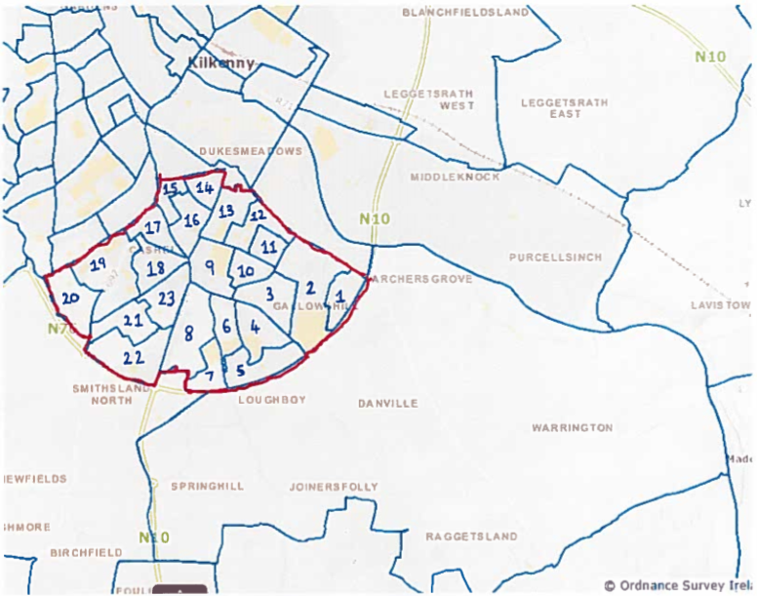
Table 1 - Small Area (SA) Codes
1 = 097063023 | 7 = 097063021 | 13 = 097063014 | 19 = 097063017
2 = 097063024 | 8 = 097063054 | 14 = 097062003 | 20 = 097063015
3 = 097063029 | 9 = 097063028 | 15 = 097062004 | 21 = 097063019
4 = 097063027 | 10 = 097063030 | 16 = 097062001 | 22 = 097063020
5 = 097063025 | 11 = 097063031 | 17 = 097061001 | 23 = 097063018
6 = 097063026 | 12 = 097063032 | 18 = 097063016

The 376 SA population sizes in Kilkenny at the 2016 Census ranged from lowest 79 to highest 573. Chart 1 shows the population size of each of the 23 Small Areas of interest in this analysis. The population size of these range from 129 (SA 15) to 377 (SA 20). The largest population change was a 19.3% increase in population between the intercensal period for Small Area 097063015 and the biggest decrease was seen in Small Area 097063030 at -8.7%. Looking at all areas collectively, the population size increased from 5,672 in 2011 to 5,823 in 2016, a 2.6% increase.

Using the Relative HP (Haase and Pratschke) scores we can gain an understanding of the of overall affluence and deprivation of each of the SAs. Figure 1 shows the Relative Index scores of each of the selected SAs at a point in time, by using the latest census data (2016). The relative scores can be categorised and labelled as follows:

Categorisation/Labelling of Relative Index Scores
- below -30 (extremely disadvantaged);
- -20 to -30 (very disadvantaged);
- -10 to -20 (disadvantaged);
- 0 to -10 (marginally below average);
- 0 to 10 (marginally above average);
- 10 to 20 (affluent);
- 20 to 30 (very affluent);
- above 30 (extremely affluent).
Figure 1 shows that the SA deprivation scores range from lowest -19.9 (“disadvantaged”) through to highest 15.5 (“affluent”), with only three SAs classified as “disadvantaged”, six as “affluent”, and the remaining fourteen SAs split equally between “marginally below” and “marginally above” average. Looking at the Small Areas collectively to ‘approximate’ Loughboy, a deprivation score can be calculated by multiplying each Small Area score by the Small Area population, then summing all of these and dividing by the sum of each Small Area populations. The resulting deprivation score is 2.4 categorised as ‘marginally above average’.

To aid in interpreting the HP Deprivation Scores, eight of the eleven indicators (listed in bullet point format below) used in the construction of the score will be presented in the Table 2 to allow comparison of Loughboy (‘approximation’) and County Kilkenny. Note that the percentage change in population over the previous five years (positive association) was shown earlier and ‘the mean number of persons per room’ (negative association) indicator is not included since the data for this was not acquired. An additional two indicators related to housing tenure that are not included in the score, but are nevertheless highly informative, are also be presented, namely Local Authority and Privately rented accommodation. Dependency ratios will be shown and are used to give a useful indication of the age structure of a population with young (0-14) and old (65+) shown as a percentage of the population of working age (15-64), along with combined measure (young and old). Ethnicity will also be shown.
- The percentage of population aged under 15 or over 64 years of age (negative association)
- The percentage of population with a primary school education only (negative association)
- The percentage of population with a third level education (positive association)
- The percentage of households with children aged under 15 years and headed by a single parent (negative association)
- The percentage of households headed by professionals or managerial and technical employees, including farmers with 100 acres or more (positive association)
- The percentage of households headed by semi-skilled or unskilled manual workers, including farmers with less than 30 acres (negative association)
- The male unemployment rate (negative association)
- The female unemployment rate (negative association)
Table 2 consists of each individual indicator (e.g. % of Male Unemployment) for Loughboy (‘approximation’), along with both the indicator numerator (e.g. 'Number of persons looking for first regular job or unemployed having lost or given up previous job’) and denominator (e.g. Numerator + ‘Number of persons at work’). For comparison also, the indicator measures are provided for County Kilkenny and the percentage point difference between Loughboy (‘approximation’) and County Kilkenny are provided also.

Table 2 - Profile Indicator Summaries
Indicator | Numerator | Denominator | Loughboy¹ (%) | County Kilkenny (%) | Percentage Point Difference
Age Dependency | 1,812 | 4,011 | 45.2 | 56.5 | -11.3
Young Dependency | 1,091 | 4,011 | 27.2 | 34.3 | -7.1
Old Dependency | 721 | 4,011 | 18.0 | 22.2 | -4.2
Population aged under 15 or over 64 | 1,813 | 5,823 | 31.1 | 36.1 | -5.0
White Irish | 4,892 | 5,767 | 84.8 | 87.8 | -3.0
White Irish Traveller | 6 | 5,767 | 0.1 | 0.6 | -0.5
Other Ethnic Background | 805 | 5,767 | 14.0 | 10.1 | 3.9
Female unemployment | 132 | 1,487 | 8.9 | 11.4 | -2.5
Male unemployment | 218 | 1,581 | 13.8 | 13.9 | -0.1
Third level education | 1,513 | 3,909 | 38.7 | 31.7 | 7.0
Lower education | 394 | 3,909 | 10.1 | 13.0 | -2.9
Professional classes | 2,263 | 5,823 | 38.9 | 37.2 | 1.7
Semi/Unskilled classes | 769 | 5,097 | 15.1 | 17.0 | -1.9
Lone parents | 148 | 619 | 23.9 | 17.9 | 6.0
Local authority rented accommodation | 231 | 2,221 | 10.4 | 8.6 | 1.8
Privately rented accommodation | 476 | 2,221 | 21.4 | 14.0 | 7.4
- Approximation of Loughboy made up of 23 Small Areas as detailed in Table 1
Population figures
Population age groups of interest for Callan Work House Union are shown in Table 3 and 4 below, reflecting numbers and percentages respectively.
Table 3: Population numbers in selected age groups for Loughboy (‘approximation’)
Sex | 0 to 5 | 6 to 12 | 13 to 19 | 20 to 24 | 65 plus
Male | 263 | 227 | 247 | 142 | 314
Female | 231 | 242 | 213 | 138 | 314
Total | 494 | 469 | 460 | 280 | 721
Table 4: Population numbers in selected age groups as percentage of total Loughboy (‘approximation’) population
Sex | 0 to 5 | 6 to 12 | 13 to 19 | 20 to 24 | 65 plus
Male | 4.6 | 3.9 | 4.3 | 2.5 | 5.4
Female | 4.0 | 4.2 | 3.7 | 2.4 | 5.4
Total | 8.6 | 8.1 | 8.0 | 4.9 | 12.5

Usually resident population by Non-Irish nationality
The number of usually resident population in Loughboy (‘approximation’) was 5,767 at the 2016 Census. Table 5 shows the breakdown of all both Irish and Non-Irish nationality and Figure 2 presents Non-Irish breakdown.
Table 5: Usually resident population by nationality
Nationality | Number | Percentage
Ireland | 5,045 | 87.5
Other EU28 | 256 | 4.4
Poland | 197 | 3.4
UK | 97 | 1.7
Rest of world | 93 | 1.6
Not stated | 48 | 0.8
Lithuania | 31 | 0.5
Total | 5,767 | 100.0

Figure 2.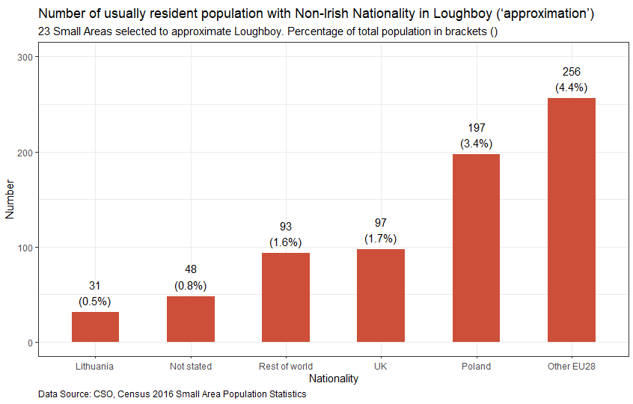

Map from CSO SAPMAP: http://census.cso.ie/sapmap/
Haase, T. & Pratschke, J. (2018) The Pobal HP Deprivation Index for Small Areas in the Republic of Ireland. Dublin: Pobal.

