COMMUNITY ENHANCEMENT PROGRAMME 2020
Reopening of Community Facilities under Covid 19 Restrictions Small Grant Support Scheme

Closing Date: Friday 24th July, 2020 at 5.00p.m.

FOR OFFICE USE ONLY

Date Received:

Reference Number:

LCDC recommendation:

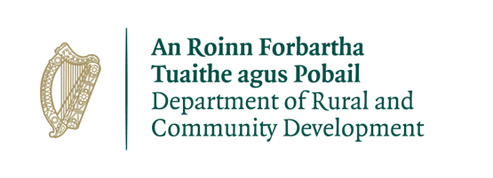

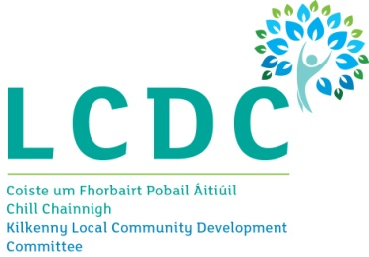

GROUP /ORGANISATION NAME:
__________________________________________________________________________________________________________________________________________________________________________________________________________________________________________

ALL APPLICATIONS ARE TO BE RETURNED TO:

Cora Nolan, Kilkenny County Council
Community Section, Johns Green House, Johns Green, Kilkenny
Or
Cora.nolan@kilkennycoco.ie
5PM FRIDAY 24th JULY, 2020
CLOSING DATE WILL BE STRICTLY ADHERED TO.

Please read the Application Guidelines before completing this form

Department of Social Protection, Community and Rural Development and the Islands
Community Enhancement Programme
The Department of Rural and Community Development (“the Department”) operates a grant programme through the Local Community Development Committees (LCDCs). This capital grant programme provides funding to enhance facilities in disadvantaged communities. Applications should relate to one or more key priority areas identified in the LCDC Local Economic and Community Plan (LECP) in order to be eligible for consideration.

All questions on this form must be answered.

SECTION 1 – YOUR ORGANISATION DETAILS AND CONTACTS:

Name of Group / Organisation / Government Department / State Agency | Please write in block capitals or type this application form
Address:  Eircode: | _____________________________________________  _____________________________________________  _____________________________________________

Contact name:

Role in Group/Organisation

Telephone number

E-mail

Website

Alternative Contact name

Alternative Telephone number

Alternative E-mail

Charitable Status Number (if applicable):

Tax Clearance Access Number (if applicable):
Tax Reference Number (if applicable):

1. Please provide a brief description of the activities that take place in your hall or centre:
____________________________________________________________________________________________________________________________________________________________________________________________________________________________________________________________________________________________________________________________________________________________
_______________________________________________________________________________________
2. Have you previously received funding from Kilkenny County Council?

YES ☐ NO ☐

SECTION 2 – PROJECT DETAILS :

How much funding are you applying for?  PLEASE NOTE MAXIMUM GRANT OF €500 | €

PURPOSE OF GRANT
What will the funding be used for? Please see guidelines as to what equipment is eligible under this grant scheme
____________________________________________________________________________________________________________________________________________________________________________________________________________________________________________________________________________________________________________________________________________________________
_______________________________________________________________________________________

4. When do you expect to have the works completed? Please give a date__________________________

SECTION 3 – DECLARATION:
- I declare that the information given in this form is correct.
- I confirm I have read and fully understand the Terms and Conditions of the Community Enhancement Programme
- I confirm that I have read the Community Enhancement Programme Application Reopening of
- Community Centres under Covid 19 Restrictions Grant Support Scheme Guidelines prior to completing this form.
- I confirm that this grant application is submitted in acceptance of and compliance with the Terms and Conditions.
- I confirm that the applicant group/organisation does not have the funding to undertake the work/project without this grant aid and is not receiving support from any other source for this project.
- I confirm that the applicant group/organisation is tax compliant (if tax registered).

Name in block capitals (on behalf of group / organisation):
Signature:
Position held in group / organisation
Date:
Successful applicants will receive a Letter of Offer. If your application is successful payment will be made by EFT (Electronic Bank Transfer). If your community group are not set up on our financial system a supplier set up form will need to be completed once the letter of offer has issued and returned to Kilkenny County Council, Community Section, Johns Green House, Johns Green, Kilkenny for payment

Groups must keep a record of all expenditure to allow Kilkenny County Council to carry out an audit of their activities and send in a report with receipts to the address above by 21st August 2020.

Data Protection
Kilkenny County Council is operating this grant on behalf of Kilkenny LCDC and collects some personal data during the application and processing of this grant scheme, particularly, names, addresses and contact details (emails and telephone numbers). These details are necessary for the consideration and adjudication on the grants scheme.

The grant applications are sometimes shared between relevant County Council Departments for the purpose of supporting the application and also to ensure that similar events are not double funded, and in relation to other festival/events funded by the Council. At all stages the personal data is handled in full accordance with the Data Protection Legislation.

Your express consent is required, acknowledging that you understand that you may be submitting personal data. Please sign here by way of agreement.

Signed: ________________________________ Date: _____________________________

